Name: Hammad Ahmed Awan

Class: BSCS-VII, Sec ‘A‘

CMS-ID: 021-19-0018

Submitted To: Sir Nisar Ahmed Siddique

MOBILE APPLICATION DEVELOPMENT

LAB No.4

2022

**TASK 1**

**Question: Add an Action Menu bar to log out the user, and move the user to main activity. And also remove all activities from memory.**

**CODE:**

**package com.example.task1_menu  
  
import android.content.Intent  
import androidx.appcompat.app.AppCompatActivity  
import android.os.Bundle  
import android.view.View  
  
class MainActivity : AppCompatActivity() {  
 override fun onCreate(savedInstanceState: Bundle?) {  
 super.onCreate(savedInstanceState)  
 setContentView(R.layout.*activity_main*)  
 }  
  
 fun Next (view : View){  
  
 var intent: Intent = Intent(this , MainActivity2::class.*java*)  
 startActivity(intent)  
 finish()  
  
 }  
}**

**package com.example.task1_menu  
  
  
import android.content.Intent  
import android.os.Bundle  
import android.view.Menu  
import android.view.MenuInflater  
import android.view.MenuItem  
import androidx.appcompat.app.AppCompatActivity  
  
  
class MainActivity2 : AppCompatActivity() {  
 override fun onCreate(savedInstanceState: Bundle?) {  
 super.onCreate(savedInstanceState)  
 setContentView(R.layout.*activity_main2*)  
 }  
  
 override fun onCreateOptionsMenu(menu: Menu?): Boolean {  
 val inflater: MenuInflater = *menuInflater* inflater.inflate(R.menu.*mainmenu* , menu)  
 return true  
 }  
  
 override fun onOptionsItemSelected(item: MenuItem) = when (item.*itemId*) {  
  
  
 R.id.*Log* -> {  
 var intent: Intent = Intent(this, MainActivity::class.*java*)  
  
 intent.*flags* = Intent.*FLAG_ACTIVITY_CLEAR_TASK* or Intent.*FLAG_ACTIVITY_NEW_TASK* startActivity(intent)  
  
 true  
 }  
  
 else -> {  
 // If we got here, the user's action was not recognized.  
 // Invoke the superclass to handle it.  
 super.onOptionsItemSelected(item)  
 }  
 }  
  
  
}**

**<?xml version="1.0" encoding="utf-8"?>  
<menu xmlns:app="http://schemas.android.com/apk/res-auto"  
 xmlns:android="http://schemas.android.com/apk/res/android">  
  
 <item  
 android:id="@+id/Home"  
 android:title="Home | "  
 app:showAsAction="ifRoom" />  
  
 <item  
 android:id="@+id/Log"  
 android:title="Logout"  
 app:showAsAction="ifRoom" />  
</menu>**

**OUTPUT:**

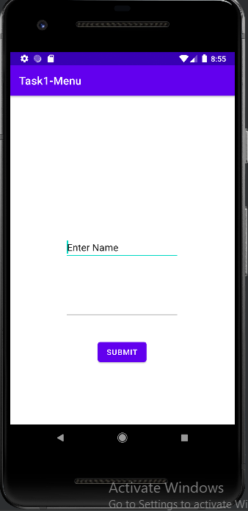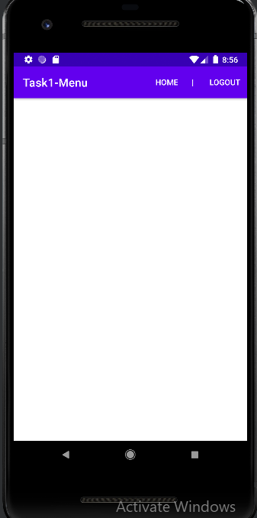

**TASK 2**

**Create floating context menu and Contextual Action Bar**

**• Task 1: Create an app with a single picture in center, on holding which the menu on left should be created.**

**• Task 2: Create a Contextual Action Bar shown on right side of the picture**

**CODE:**

**<?xml version="1.0" encoding="utf-8"?>  
<menu xmlns:android="http://schemas.android.com/apk/res/android">  
  
 <item  
 android:id="@+id/downlaod"  
 android:title="Download Image"/>  
  
 <item  
 android:id="@+id/open"  
 android:title="Open Image in new Tab"/>  
  
 <item  
 android:id="@+id/search"  
 android:title="Search google for this image"/>  
  
 <item  
 android:id="@+id/share"  
 android:title="Share Image"/>  
  
  
</menu>**

**<?xml version="1.0" encoding="utf-8"?>  
<menu xmlns:app="http://schemas.android.com/apk/res-auto"  
 xmlns:android="http://schemas.android.com/apk/res/android">  
  
 <item  
 android:id="@+id/option_1"  
 android:icon="@drawable/email"  
 android:title="Option 1" />  
  
 <item  
 android:id="@+id/option_2"  
 android:icon="@drawable/pin"**

**android:title="Option 2" />  
  
 <item  
 android:id="@+id/option_3"  
 android:icon="@drawable/download"  
 android:title="Option 3" />  
  
 <item  
 android:id="@+id/option_4"  
 android:icon="@drawable/pin"  
 android:title="Option 4" />  
  
 <item  
 android:id="@+id/insert_random"  
 android:title="insert_random" />  
  
  
</menu>**

**package com.example.task2_othermenus  
  
  
import android.os.Bundle  
import android.view.*  
import android.widget.Button  
import android.widget.ImageView  
import androidx.appcompat.app.AppCompatActivity  
  
  
class MainActivity : AppCompatActivity() {  
  
  
 override fun onCreate(savedInstanceState: Bundle?) {  
 super.onCreate(savedInstanceState)  
 setContentView(R.layout.*activity_main*)  
  
 val img1: ImageView = findViewById(R.id.*imageView*)  
 registerForContextMenu(img1)  
  
 val btn1: Button = findViewById(R.id.*button*)  
 btn1.setOnLongClickListener {  
 startActionMode(actionModeCallback)  
 true  
 }  
 }  
  
 override fun onCreateContextMenu(  
 menu: ContextMenu?,  
 v: View?,  
 menuInfo: ContextMenu.ContextMenuInfo?  
 ) {  
 super.onCreateContextMenu(menu, v, menuInfo)  
 menu?.setHeaderTitle("Image result for avatar ")  
 val inflater: MenuInflater = *menuInflater* inflater.inflate(R.menu.*float_menu*, menu)  
 }  
  
 private val actionModeCallback = object : ActionMode.Callback {  
 override fun onCreateActionMode(mode: ActionMode, menu: Menu): Boolean {  
 *menuInflater*.inflate(R.menu.*context_menu*, menu)  
 return true  
 }  
  
  
 override fun onPrepareActionMode(mode: ActionMode, menu: Menu) = false  
 override fun onActionItemClicked(p0: ActionMode?, p1: MenuItem?): Boolean {  
 *TODO*("Not yet implemented")  
 }  
  
 override fun onDestroyActionMode(mode: ActionMode) {}  
 }  
  
 }**

**OUTPUT:**

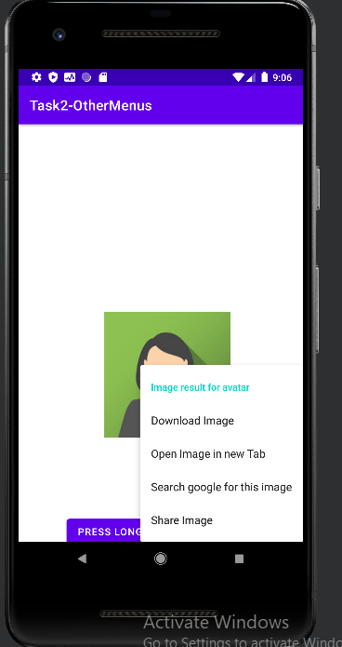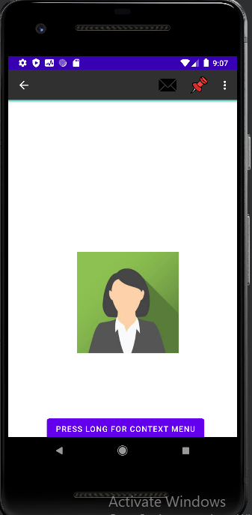

**TASK 3**

**Add following options in the menu**

**- Music On / Off button in Menu (To turn on and turn off Music, which will be played from internet)**

**- Speak Button (To speak a sentence written in textbox)**

**Add both as “showAsAction = Always”, use suitable icons**

**CODE:**

**<?xml version="1.0" encoding="utf-8"?>  
<menu xmlns:android="http://schemas.android.com/apk/res/android"  
 xmlns:app="http://schemas.android.com/apk/res-auto">  
  
 <item  
 android:id="@+id/on"  
 android:title="Music ON"  
 android:icon="@drawable/sound"  
 app:showAsAction= "always" />  
  
 <item  
 android:id="@+id/off"  
 android:title="Music Off"  
 android:icon="@drawable/mute"  
 app:showAsAction="always" />  
  
  
 <item  
 android:id="@+id/speak"  
 android:title="Speak"  
 android:icon="@drawable/rumor"  
  
 app:showAsAction="always" />  
  
</menu>**

**package com.example.task3  
  
import android.content.Intent  
import android.media.AudioManager  
import android.media.MediaPlayer  
import androidx.appcompat.app.AppCompatActivity  
import android.os.Bundle  
import android.speech.tts.TextToSpeech  
import android.view.Menu  
import android.view.MenuInflater  
import android.view.MenuItem  
import android.widget.AdapterView  
import android.widget.ListView  
import android.widget.TextView  
import android.widget.Toast  
import java.io.IOException  
  
class MainActivity : AppCompatActivity() {  
 var flag = false  
 var mediaPlayer : MediaPlayer? = null  
 var tts: TextToSpeech? = null  
  
 override fun onCreate(savedInstanceState: Bundle?) {  
 super.onCreate(savedInstanceState)  
 setContentView(R.layout.*activity_main*)  
  
  
 tts = TextToSpeech(this , TextToSpeech.OnInitListener {  
 flag = true  
 })  
  
  
  
  
  
 }  
  
 override fun onCreateOptionsMenu(menu: Menu?): Boolean {  
 val inflater: MenuInflater = *menuInflater* inflater.inflate(R.menu.*main_menu* , menu)  
 return true  
 }  
  
 override fun onOptionsItemSelected(item: MenuItem) = when (item.*itemId*) {  
  
  
 R.id.*on* -> {  
 val audioURL = " https://www.learningcontainer.com/wp-content/uploads/2020/02/Kalimba.mp3"  
 mediaPlayer = MediaPlayer()  
 mediaPlayer!!.setAudioStreamType(AudioManager.*STREAM_MUSIC*)  
  
 try{  
 mediaPlayer!!.setDataSource(audioURL)  
 mediaPlayer!!.prepare()  
 mediaPlayer!!.start()  
 }catch (e : IOException){  
 e.printStackTrace()  
 }  
  
 Toast.makeText(this , "Audio started playing" , Toast.*LENGTH_LONG*).show()  
  
 true  
 }  
  
 R.id.*off* -> {  
  
 if(mediaPlayer!!.*isPlaying*) {  
 mediaPlayer!!.stop()  
 mediaPlayer!!.reset()  
 mediaPlayer!!.release()  
 }  
  
 else{  
 Toast.makeText(this , "Audio paused" , Toast.*LENGTH_LONG*).show()  
 }  
 true  
 }  
  
 R.id.*speak* -> {  
 val txt1 : TextView = findViewById(R.id.*textView*)  
 val txt2 = txt1!!.*text*.toString()  
 tts!!.speak(txt2 , TextToSpeech.*QUEUE_FLUSH* , null , "")  
 true  
 }  
  
 else -> {  
 // If we got here, the user's action was not recognized.  
 // Invoke the superclass to handle it.  
 super.onOptionsItemSelected(item)  
 }  
 }  
  
 public override fun onDestroy() {  
 // Shutdown TTS  
 if (tts != null) {  
 tts!!.stop()  
 tts!!.shutdown()  
 }  
 super.onDestroy()  
 }  
  
}**

**OUTPUT**

